CHURCHVILLE GREENE HOMEOWNERS ASSOCIATION, INC.

VINYL FENCE VARIANCE REQUEST

PLEASE RETURN COMPLETED FORM TO:  Churchville Greene Homeowners Association  C/o Realty Performance Group, Inc.  1800 Hudson Avenue, Suite 100  Rochester, NY 14617  PROPERTY: ________________________________ | HOMEOWNER: _________________________  ADDRESS: ______________________________  PHONE: Daytime: _________________________  Evening: _________________________

TO THE BOARD OF DIRECTORS:
I REQUEST PERMISSION TO MAKE THE FOLLOWING CHANGES TO THE EXTERIOR OF MY TOWNHOUSE OR TO THE COMMON AREA OF THE COMMUNITY. I UNDERSTAND THAT IT IS MY RESPONSIBILITY TO OBTAIN ANY BUILDING PERMITS THAT MAY BE NECESSARY FOR THIS WORK. I HAVE ATTACHED A SKETCH OF PROPOSED CHANGES, LISTED MATERIALS TO BE USED, AND INDICATED WHO WILL DO THE WORK (please be explicit; extra sheets may be attached).
________________________________________________________________________________________________________________________________________________________________________________________________________________________________________________________________________________________________________________________________________________________________________________________________________________________________________________
____________________________________________________________________________________________________________
REASON FOR VARIANCE REQUEST: ________________________________________________________________________________________________________________________________________________________________________________________________________________________

WHO WILL COMPLETE THE WORK? (All Manufacturer/Suppliers must provide RPG a certificate of insurance evidencing appropriate liability and workers compensation insurance): _________________________________

LENGTH OF GUARANTEE (If applicable): _____________________________________________________

INDICATE ANY FUTURE MAINTENANCE REQUIRED BY THE ASSOCIAITON:
__________________________________________________________________________________________

_________________ ______________________________________
DATE SIGNATURE OF PETITOINER

===========================================================================================

BOARD OF DIRECTORS ACTION: _________ APPROVED _________ DENIED

_____________________ __________________________________________________________
DATE AUTHORIZED SIGNATURE

COMMENTS: _________________________________________________________________________________________
_____________________________________________________________________________________________________
_____________________________________________________________________________________________________

LATEST COMPLETION DATE AFTER WHICH ANY APPROVAL IS AUTOMATICALLY REVOKED AND NEW
VARIANCE REQUEST IS NECESSARY: __________________________________________________________________
DATE ON WHICH ACTED-ON VARIANCE REQUEST MAILED TO PETITIONER_______________________________

CHURCHVILLE GREENE HOMEOWNERS ASSOCIATION, INC.
VARIANCE REQUEST CHECKLIST FOR VINYL FENCES

Choose 1 Approved Manufacturer/Supplier:
New York State Fence All American Fence
858 Manitou Rd, 616 Trimmer Road
Hilton, NY. 14468 Spencerport, NY 14559
(585) 392-3222 (585) 352-8370

Select (1) Approved Fence Style (See Pages 4-7)

VINYL FENCE GUIDELINES:

Is there a Meter Chase in your patio area? Yes_____ No_____

- If the land topography (hills or embankments) requires fencing that is shorter than 5 feet to effect a level fence height, this must be specified on the Variance Request. If the terrain is uneven, you must attach proposed plan/sketch of different fence heights. The Manufacturer/Supplier can provide this when estimating the job.

- Residents are required to use one of the above approved Manufacturers/Suppliers for the removal and replacement of any existing fence. When replacing a fence it is required to contact 811 (Dig Safely New York) prior to starting the job, but it is your responsibility to ask the Manufacturer/Supplier prior to any removal and installation. If a Homeowner is self-installing a fence, then the Homeowner must contact 811 directly to schedule the stakeout before work begins. Any resident who fails to comply with this requirement is responsible for any underground utility damages and repairs that are subsequently required.

- Should a homeowner choose to install their own fencing, he/she is required to use only one of the approved Manufacturers/Suppliers and one of the approved fence styles. If any product (fencing) or installation work does not meet the standards of this Variance, the homeowner will be required to have the fence removed.

- An additional responsibility of the homeowner and contractor is to insure the integrity of the drainage system that connects the roof gutter to any above ground piping, and to any underground piping that connects to the storm sewer. If this system is damaged during the fence replacement/repair process, it must be reinstated back to its original functioning condition.

- Any fence that is installed by a Manufacturer/Supplier will not incur any sales tax as this is considered a Capital Improvement.

- Any Homeowner installed fence will incur the sales tax charge for materials.

- The removal of the existing fence and proper disposal is the homeowners’ responsibility. Most Manufacturers/Suppliers will price this into their contract.

- The removal of the existing concrete post footers is required due to the fact that the vinyl fence posts are 5” x 5” prior to installing a new vinyl fence. Again, the proper disposal is the homeowners’ responsibility and most Manufacturers/Suppliers will price this into their contract.

- The new fence must be in the same footprint of the existing fence with consideration being given to the larger fence post.

- All fence post holes are required to be a minimum of 30” deep from the surrounding surface for frost movement protection.

- All fence posts are to be 5” square and of a routed design. Bracketed fences are not allowed. Pressure treated lumber posts wrapped in vinyl will not accommodate the routed design; thus they are not allowed.

- All fence posts need to be set in a minimum of 120 lbs. of WET MIX concrete (1½ 80 lb. bags). Dumping a bag of Dry Concrete Mix into the fence posts holes will NOT be accepted.

- The gate post on the hinge side must have a metal stiffener in order to bear the weight of the swinging gate.

- The bottom rail must have galvanized steel reinforcement channel to avoid fence panels from sagging.

- Metal stiffeners are available for all end posts, joining posts, and latch side of the fence gate for added strength, if preferred. Corner posts are not available with stiffeners.

- Fence height will be required to be 5 or 6 feet with a matching gate height.

- Gate latches must make it accessible for opening from both sides of the gate. This is due to fire codes.

- Gate latches and hinges must be black in color. Hinges are to be of a metal composition.

- Post caps are to be a flat (Colonial) style. Solar lighted flat post caps are available and acceptable..

- Color of fence will be limited to white or almond, dependent upon the manufacturer. Fence panels, posts and gates must be all of the same color.

- The following are the approved manufacturers, suppliers, and styles. Each manufacturer may have a different name for the four approved styles.

- Not all styles/heights are available from all manufacturers.

Colors Available: (Check with the Manufacturer):

SMOOTH WHITE SMOOTH ALMOND
(Non-textured) (Non-textured)

Style(s) Available:

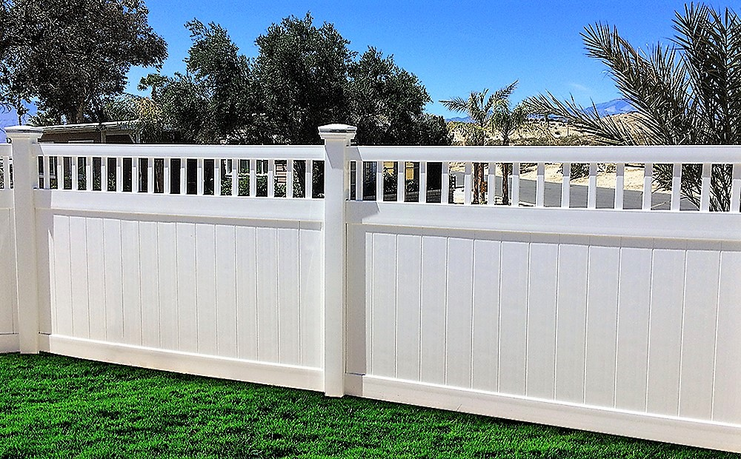

Manufacturer
All American Fence Style Name Height
WeatherWise Imperial 6’ only
Platinum Vinyl Surry 6” only
New York State Fence Solid Board with Victorian Top 5’ or 6’

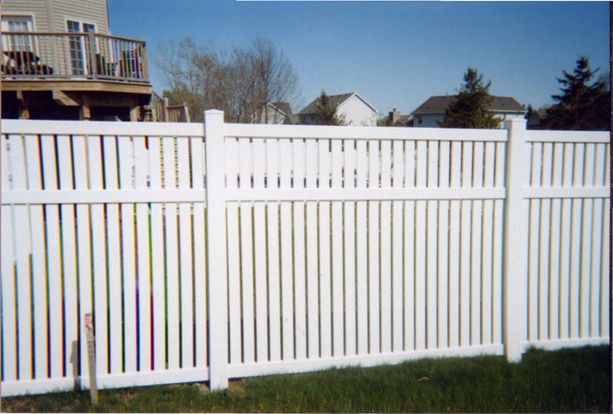

Manufacturer Style Name Height
All American Fence
WeatherWise Outerbanks 5’ or 6’
CertainTeed Select Series Bel Air (3” boards, 7/8 spacing) 5’ or 6’
New York State Fence Semi-privacy Board (3” boards, 3/4 spacing) 5’ or 6’
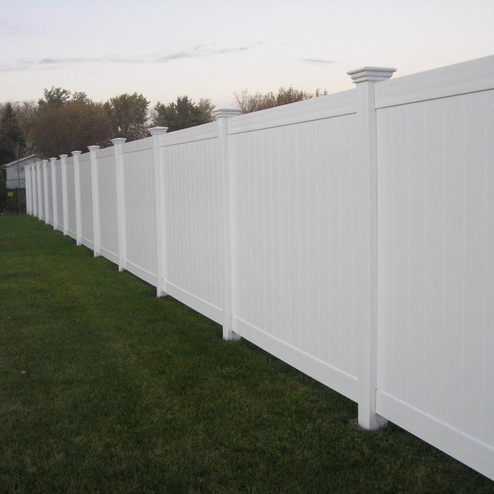

Manufacturer Style Name Height
All American Fence
WeatherWise Cambridge 5’ or 6’
Platinum Vinyl Seneca 6’ only
CertainTeed Select Series Arlington Smooth 5’ or 6’
New York State Fence Solid Board 5’ or 6’

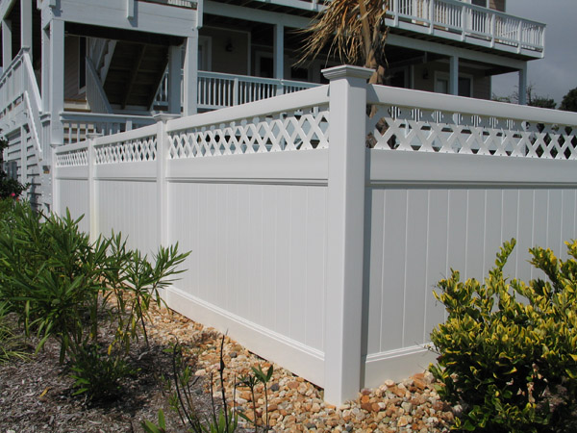

Manufacturer Style Name Height
All American Fence
WeatherWise Oxford 5’ or 6’
Platinum Caspian 6’ only
CertainTeed Select Series Arlington with Lattice 6’ only
New York State Fence Solid Board with Lattice Top 5’ or 6’

